UNA-UK’s UN quiz

Here are our suggestions for questions you can ask on your quiz night. Feel free to make up your own questions too.

Round 1: Quiz questions

- How many member states does the UN have today?
- How many people does the UN provide food to (rounded to the nearest million)?
- Name the ‘principal organs’ of the UN as mentioned in the UN Charter.
- Roughly how many dollars in humanitarian aid does the UN mobilise each year?
- What international organisation was a precursor to the UN, and failed to prevent the Second World War?
- On what date did the UN Charter enter into force?
- How many UN member states were there when the UN was founded?
- Who was the first person to lead the UN and where was he from?
- Where were the first meetings of the UN General Assembly held?
- How many times has the UK exercised its veto power in the UN Security Council?
- How many refugees worldwide does the UN assist each year, rounded to the nearest million?
- When is the international day of UN Peacekeepers?
- On what day of the week does the UN GA begin its regular sessions annually?
- Who is the current UK Permanent Representative to the UN?
- Who is the current UN Secretary-General?
- The UK contributes 705 UN peacekeepers, including police, soldiers and civilian experts. Name the two countries that host the most UK peacekeepers?
- Two SGs have won Nobel Peace Prizes – name them!
- How many times has the UN and its specialist agencies won the Nobel prize?
- Only 3 women have been selected by states as UNGA president. Can you name the 3 countries they were from?
- How many ‘peacekeepers’ operate currently, rounded to the nearest hundred thousand?
- How is the seating order for member states determined in the UN General Assembly?
- Whose speech to the General Assembly was paraphrased and set to music by Bob Marley?
- How long is the UN’s longest peacekeeping mission?
- What’s out of the ordinary about the sculpture of a gun outside the UN HQ building in New York?

Round 2: Flags

1. What country does this flag belong to?
2. Bonus point: When did this country join the UN?
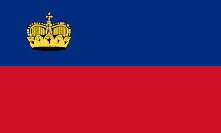
1.

2.
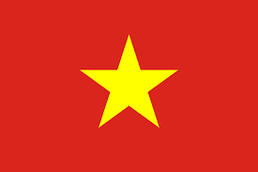
3.

4.
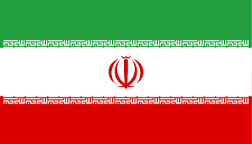
5.

6.
7.

8.
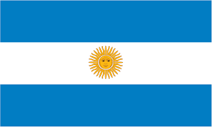
9.

10.
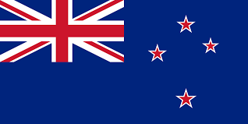
11.

12.
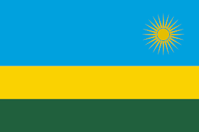
13.

14.
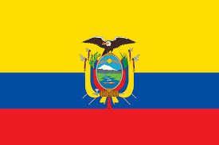
15.

16.
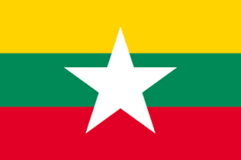
17.

18.
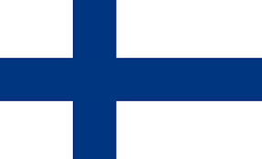
19.

20.

Round 3: People

- Who is this?
- What is his/her role at the UN?

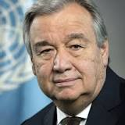 | - Who is this? | - What is his/her role at the UN?
 | - Who is this? | - What is his/her role at the UN?
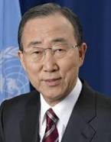 | - Who is this? | - What is his/her role at the UN?
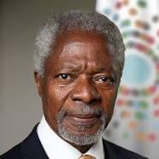 | - Who is this? | - What is his/her role at the UN?
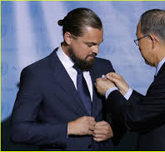 | - Who is this? | - What is his/her role at the UN?
Answers to round 1:

- The UN has now 193 member states.
- The UN provides food to roughly 90M people each year (correct if answer is 10M above or below).
- The organs are as follows: General Assembly, Security Council, Economic and Social Council (ECOSOC), International Court of Justice and Secretariat. The Trusteeship Council disbanded in 1994 so is not one of the main bodies of the UN anymore but is mentioned in the UN charter.
- The UN mobilises $12.5 billion in humanitarian aid (correct if answer is between £10 billion - £15 billion).
- The League of Nations came before the UN.
- The official UN Charter was ratified on the 24 Oct 1945.
- 51 states are the original members of the UN.
- The first person was Gladwyn Jebb (from Oct 1945 to Feb 1946) and he was from Britain.
- The first meetings of UNGA were held at Westminster Central Hall (UNSC at Church House, Westminster).
- The UK exercised its veto power in the UN Security Council on 29 occasions (and hasn’t used it since 1989).
- UN assists over 65M refugees and people fleeing war, famine or persecution (correct if answer is 10M above or below).
- The International Day of UN Peacekeepers is on the 29th of May
- Tuesday: UN GA regular sessions begin every year on the third Tuesday in September.
- The current UK Perm Representative to the UN is Ambassador Matthew Rycroft.
- António Guterres (he is the 9th UNSG.)
- Cyprus and South Sudan
- Two SGs have won the Nobel prize: Kofi Annan and Dag Hammarskjöld
- Within 70 years, the United Nations, its specialised agencies, related agencies, funds, programmes and staff were awarded the Nobel Peace Prize 11 times.
- The women selected for UNGA presidency were from India, Bahrain and Liberia (Vijaya Lakshmi Pandit, Sheikha Haya Rashed Al Khalifa and Angie Elisabeth Brooks)
- The UN works to keep peace with 120,000 peacekeepers across 4 continents.
- In advance of the session the Secretary-General picks a name at random and they sit in the “first” seat at the front left of the Assembly. All other countries then sit in alphabetical order following that country. In the current session, the Czech Republic was picked to go in the first seat.
- Emperor Haile Selassie of Ethiopia’s speech to the 1963 General Assembly includes the line that “until the philosophy which holds one race superior and another inferior is finally and permanently discredited and abandoned… the African continent will not know peace” and forms the key refrain in Bob Marley’s 1976 hit “war”.
- The UN’s longest peacekeeping mission is in the Israeli occupied territories. 69 years and counting!
- Swedish artist Carl Fredrik Reuterswärd designed the sculpture with a knotted barrel.

Answers to round 2: flags
- Liechtenstein
- 1990
- Viet Nam
- 1977
- Iran
- 1945
- Belgium
- 1945
- Argentina
- 1945
- New Zealand
- 1945
- Rwanda
- 1962
- Ecuador
- 1945
- Myanmar
- 1948
- Finland
- 1955

Answers to round 3: people

- António Guterres
- Guterres became the Secretary-General of the United Nations on 1 January 2017. He is serving as the ninth Secretary-General of the United Nations. Previously, he was the United Nations High Commissioner for Refugees between 2005 and 2015.
- Angelina Jolie
- In 2012 she was appointed as the Special Envoy to the United Nations High Commissioner for Refugees.
- Ban Ki-moon
- Ban Ki-moon is the former Secretary-General. He was the eighth Secretary-General of the United Nations. Mr. Ban held office from 1 January 2007 to 31 December 2016.
- Kofi Annan
- Kofi Annan served as the seventh Secretary-General of the United Nations from January 1997 to December 2006.
- Leonardo DiCaprio
- Leonardo DiCaprio was designated as the UN Messenger of Peace. Messengers of Peace are individuals who possess widely recognized talents in the fields of art, film, literature, music and sports, helping to raise worldwide awareness of the Organization’s ideals and activities.

